FORM 2
THE PATENTS ACT, 1970 &
THE PATENTS RULES, 2003
COMPLETE SPECIFICATION
“Gesture-Controlled Autonomous Navigation System using Robot Operating System 2”
APPLICANT
Name | Nationality | Address
Chennai Institute of Technology | An Indian National | Chennai Institute of Technology  Kundrathur,  Chennai- 600 069  Email: principal@citchennai.net
The following specification particularly describes the invention and the manner in which it is to be performed
Description
Title of the invention: “Gesture-Controlled Autonomous Navigation System using Robot Operating System 2”
Field of the Invention: Robotic and Automation Field (Mechatronics Engineering)
The invention is in the realm of automation and robotics, dealing with sophisticated locomotion systems for autonomous mobile robots. More specifically, this invention presents a hybrid control system for a four-wheeled robot that supports motion based on hand gestures by a capacitive touch sensor, a magnetometer, and an ultrasonic sensor. The system is optimized for effortless use in the Gazebo simulation environment, providing efficient and intuitive robot movement.
This invention has potential applications in areas such as industrial automation, assistive robotics, and autonomous control of vehicles. By combining gesture control with sensor-based navigation, the invention boosts the responsiveness and adaptability of robotic systems under dynamic conditions.
BACKGROUND OF INVENTION/ PRIOR ART:
The robotics discipline has developed substantially over the last century, and significant developments in autonomous mobile robots (AMRs) have been made in recent decades. AMRs were conceptualized in the 1960s when researchers at Stanford and MIT created the first versions of mobile robots that could move in simple environments using simple sensors. In the 1980s, Carnegie Mellon University developed autonomous robotic systems that could map and navigate unfamiliar environments, a major breakthrough in robotic mobility.
Gesture control systems started gaining popularity in the 1990s with the development of wearable sensor technologies like accelerometers and gyroscopes, enabling users to operate robotic devices by detecting motion. These early systems were, however, hampered by high latency and imprecision. By the early 2000s, vision-based gesture recognition, employing cameras and computer vision algorithms, was a widely researched topic. Although there were improvements, these systems were limited by factors like sensitivity to lighting conditions, high computational demands, and vulnerability to errors caused by occlusions.
During the 2010s, capacitive touch sensors and magnetometers were among the promising technologies to be developed for gesture recognition. These sensors offered more dependable input mechanisms, as they remained unimpaired by visual obstacles and could work efficiently in a variety of environmental conditions. Ultrasonic sensors, utilized in robots since the 1970s for detecting obstacles, also improved and enabled robots to move autonomously through intricate spaces without crashing.
Although existing research and business innovations have touched on single technologies such as capacitive touch sensors, magnetometers, and ultrasonic sensors in robotics, an integrated solution that consolidates these technologies for intuitive gesture-based control is in its nascent stages. This innovation fills the void with a hybrid locomotion control system utilizing capacitive touch sensors, magnetometers, and ultrasonic sensors for effective real-time robot motion in a simulated environment of Gazebo
OBJECTIVES OF INVENTION
1. Creating an Effective Gesture-Based Control System:
- Design and develop a hybrid locomotion control system that allows a four-wheeled robot to be controlled by hand gestures.
- Employ capacitive touch sensors and magnetometers to precisely recognize user gestures for movement control.
2. Improving Autonomous Navigation:
- Implement ultrasonic sensors for real-time obstacle detection and avoidance.
- Provide smooth and safe navigation of the robot in both simulated and real environments.
3. Seamless Integration with Gazebo Simulation:
- Deploy the gesture-based control system on the Gazebo simulation environment.

- Offer a real-world simulation setting for robot motion and obstacle interaction testing prior to real-world application.
4. Enhancing Response Time and Accuracy:
- Tune data processing algorithms to reduce response time lag between user gesture and robot motion.
- Enhance robot motion precision by improving sensor calibration and input filtering methods.
5. Ensuring Robust Communication between Components:
- Implement a secure communication protocol among the sensors, ROS2 infrastructure, and control system of the robot.
- Implement data transmission in a seamless manner to avoid delay or misinterpretation of movements.
6. Making It More Accessible and Easy to Use:
- Create an easy-to-use system that does not need extensive training for users to command the robot.
- Make the design user-friendly and scalable for diverse applications such as industrial, healthcare, and personal care.
7. Enabling Future Development and Scalability:
- Design the system modularly to enable future expansion, for example, adding more sensors or AI-driven gesture recognition.
- Make it compatible with various robotic platforms other than the four-wheeled robot.

SUMMARY OF INVENTIONS

- A four-wheeled robot controlled by gestures with capacitive touch sensors, a magnetometer, and an ultrasonic sensor is an advance in natural robotic control and autonomous navigation. This invention combines ROS2 and sensor-based gesture recognition, allowing users to easily and accurately control the robot within the Gazebo simulation environment.
- The system enables the movement of the robot to be controlled using simple hand movements, in place of conventional joysticks or manual controllers. The ultrasonic sensor identifies hand movements, and the magnetometer provides precise direction input. The ultrasonic sensor also facilitates real-time obstacles detection, making the robot more autonomous in movement and able to avoid impacts.
- By integrating these technologies, the invention offers a highly responsive, user-friendly, and efficient control mechanism. Integration with Gazebo enables extensive testing and simulation prior to real-world implementation, guaranteeing stability and performance optimization. This method not only enhances human-robot interaction but also increases potential applications in industrial automation, assistive robotics, and smart mobility solutions.

Detailed Description of the Invention

The main objective of this invention is to facilitate gesture control of a four-wheeled robot with a capacitive touch sensor, a magnetometer, and an ultrasonic sensor. This setup enables people to control the robot naturally, without the use of conventional controllers. The capacitive touch sensor recognizes hand gestures, while the magnetometer provides directional precision. The ultrasonic sensor provides better navigation by detecting and evading obstacles in real time.
The system is applied with the ROS2 framework, which interprets sensor data and converts it into robot motion commands. The Gazebo simulation environment is employed for testing and validation purposes, providing precise performance prior to actual deployment. This invention offers an easy-to-use and effective way of robot control, enhancing accessibility and user experience in robotic use.

BLOCK DIAGRAM OF GESTURE - CONTROLLED AUTONOMOUS NAVIGATION SYSTEM USING ROBOT OPERATING SYSTEM 2:
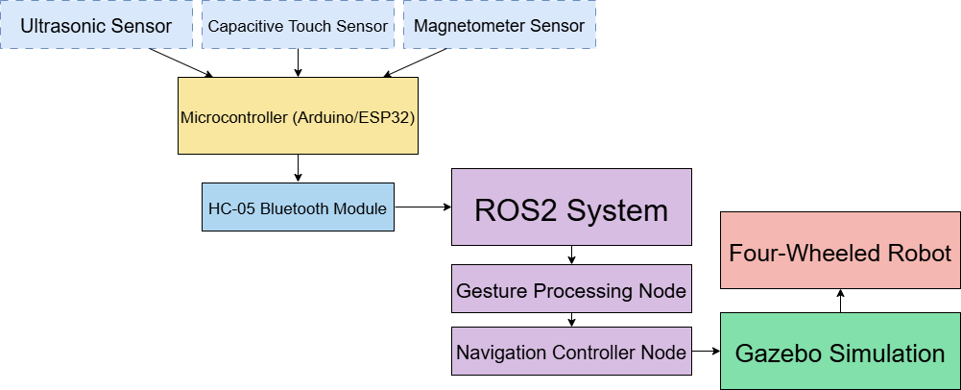

5. CLAIMS
We claim
- A hand-gesture-controlled autonomous navigation system based on a capacitive touch sensor, a magnetometer, and an ultrasonic sensor in the ROS2 environment for accurate and efficient robot movement. The system translates hand gestures into movement instructions for user-friendly interaction.
- The use of a microcontroller to handle sensor information and send signals through a Bluetooth module to the ROS2 environment to provide real-time control and responsiveness to robot movement.
- A more advanced autonomous navigation system that utilizes sensor readings to recognize obstructions and dynamically modify the path of the robot, enhancing safety and flexibility in diverse settings.
- Utilization of the Gazebo simulator for the testing and optimization of the navigation system within a simulated world, enabling performance assessment and optimization prior to actual-world use.

ABSTRACT OF THE INVENTION

This invention offers a gesture-based autonomous navigation system for a four-wheeled robot via ROS2 and a blend of capacitive touch sensors, a magnetometer, and an ultrasonic sensor. This allows real-time, hands-free robot control within the Gazebo simulation environment to enrich interactive robotics and autonomous navigation studies. The capacitive touch sensor monitors hand gestures, directional input is tracked by the magnetometer, and obstacle detection is supported by the ultrasonic sensor. These sensor inputs are processed by a microcontroller, which sends information to the ROS2 framework through Bluetooth. The system provides smooth transitions in movement and smart navigation, enabling accurate control and avoidance of obstacles. By combining ROS2 with simulation-based testing in Gazebo, the invention offers an affordable and scalable method for developing gesture-controlled robotic systems with potential applications in assistive technology, automation, and remote-controlled robotics.

